Instructions for Authors
Authors are invited to submit their manuscript in good English and in doc-format or docx-format.
Papers should be as brief as possible and must conform to the following specifications.
Article structure
Follow this order when typing manuscripts: Title, Authors, Affiliations, Abstract, Keywords, Main text, Acknowledgment, References. Figures, Figure Captions and Tables are recommended to be imported into the text.
Introduction State the objectives of the work and provide an adequate background, avoiding a detailed literature survey or a summary of the results. Figures, tables and equations should be avoided.
Experimental Provide sufficient detail to enable the experiments to be reproduced. Methods already published should be indicated by a reference and only relevant modifications should be described.
Results and Discussion This part should explore the significance of the original research results. A separated Results and Discussion section is often appropriate and may be organized into subheadings. Avoid extensive citations and discussion of published literature.
Conclusions Conclusions must be strict, scientific and objective, giving a brief summarization of the results and their significance.
Acknowledgment The acknowledgment should be brief and precede the references.
Essential title page information
Title Concise and informative. Titles are often used in information-retrieval systems. Avoid non-standard or uncommon abbreviations and formula where possible.
Author names and affiliations Please clearly indicate the given name(s) and family name(s) of each author and check that all names are accurately spelled. Signature units should be typed in English on the first page of the paper including the name of affiliation, city, postcode, province, and nation.
Corresponding author Clearly indicate who will handle correspondence at all stages of refereeing and publication, also post-publication. Ensure that academic degree, professional title, and the e-mail address are given and that contact details are kept up to date by the corresponding author.
Abstract A concise and factual abstract that summarizes the main findings of the paper in 200-250 words is required. The abstract should briefly state the purpose of the research, the main methods, the principal results and major conclusions. Non-standard or uncommon abbreviations should be avoided, or must be defined at their first mention if essential. References and formulas should also be avoided.
Key words Immediately after the abstract, provide 5-7 key words and avoid general and plural terms and multiple concepts (avoid, for example, 'and', 'of'). Be sparing with abbreviations: only abbreviations firmly established in the field may be eligible.
Nomenclature and units
Follow internationally accepted rules and conventions: use the international system of units (SI). If other quantities are mentioned, give their equivalent in SI. A symbol list is recommended when using a large amount of symbols.
Nomenclature and Units
Follow internationally accepted rules and conventions: use the international system of units (SI). Each paper should be consistent within itself as to abbreviations, symbols and units.
illustrations
• Make sure that you use uniform lettering and sizing of your original figures.
• Preferred fonts: Times New Roman, Symbol, or similar ones.
• Number the illustrations according to their sequence in the text.
• Provide captions to illustrations separately.
• Size the illustrations close to the desired dimensions of the published version.
Tables
Please submit tables as editable text and not as images. Tables should be placed next to the relevant text in the article. Number tables consecutively in accordance with their appearance in the text and place any table notes below the table body. Be sparing in the use of tables and ensure that the data presented in them do not duplicate results described elsewhere in the article. Please avoid using vertical rules.
References
More than 20 references are recommended in which books should not exceed 30%.
Text: Indicate references by number(s) in square brackets in line with the text. The actual authors can be referred to, but the reference number(s) must always be given.
Example: “..... as demonstrated in Ref.[3,6]. Barnaby and Jones ^{[8]} obtained a different result ....”
List: Number the references (numbers in square brackets) in the list in the order in which they appear in the text. For non-English references, the language should be given.
Examples:
Reference to a journal publication:
[Serial number] Authors, title, abbreviated journal name, Volume (publication year) beginning and end pages.
[1] Z. Wang, J.J. Li, L.W. Ren, Y. Zhang, J.W. Qiao, B.C. Wang, Serration Behavior in Zr-Cu-Al Glass-forming Systems, J. Iron Steel Res. Int. 23 (2016) 42-47.
[2] M. Wang, C. Zhang, F. Hu, K.M. Wu, R. Irina, Current status and trend of TRIP automotive steels, J. Iron Steel Res. 28 (2016) 1-7 (in Chinese).
Reference to a book, dissertation, report:
[Serial number] Authors, title, edition, publisher, publication location, publication year.
[3] W. Strunk Jr., E.B. White, The Elements of Style, third ed., Macmillan, New York, 1979.
Reference to a chapter in an edited book:
[Serial number] Authors, in Editor of conference proceedings (Eds.), title of conference proceedings, publisher, publication location, publication year, beginning and end pages.
[4] G.R. Mettam, L.B. Adams, in: B.S. Jones, R.Z. Smith (Eds.), Introduction to the Electronic Age, E-Publishing, Inc., New York, 1994, pp. 281–304.
Reference to a patent:
[Serial number] Authors, title, Nation, patent number, publication year.
[5] C.J. Won, Method for manufacturing hot rolled galvanized steel sheet at high speed with pickling skipped, US, 6258186B1, 2001.

- Submission checklist
During the final checking of an article prior to sending it for reviewing, please ensure that the following items are present.
The corresponding author with contact details:
• E-mail address
• Available telephone number
All necessary files have been uploaded, and contain
• Manuscript in doc-format or docx-format
Further considerations
• Manuscript has been 'spell-checked' and 'grammar-checked'
• All references mentioned in the Reference list are cited in the text, and vice versa
• Figure Captions and Tables are given in the right places
• Permission has been obtained for use of copyrighted material from other sources (including the Internet)
Example
Precipitation behavior of titanium nitride on a primary inclusion particle during solidification of bearing steel
Liang Yang^{1,2}, Bryan A. Webler², Guo-guang Cheng¹, Yuanqi Wang^{1,*}
¹ State Key Laboratory of Advanced Metallurgy, University of Science and Technology Beijing, 30 Xueyuan Road, Beijing 100083, China
² Center for Iron and Steelmaking Research, Department of Materials Science and Engineering, Carnegie Mellon University, 5000 Forbes Avenue, Pittsburgh 15213, PA, USA

ABSTRACT: Mciro-arc oxidation (MAO) was used to coat porous films on the surface of a Zr-based bulk metallic glass sample. The compressive test results indicated that, compared with the as-cast sample, the MAO treated one exhibited higher deformation capacity, associated with multiple shear bands with higher density on the side surface and well-developed vein patterns with smaller size on the fractured surface. The pore in the MAOed film and the matrix/coating interface initiated the shear bands and impeded the rapid propagation of shear bands, thus favoring the enhanced plasticity of the MAO treated sample. The results obtained demonstrated that MAO can be considered as an effective method to finely tune the mechanical performance of monolithic bulk metallic glasses.

Key words:
Bulk metallic glass
Micro-arc oxidation
Plasticity
Surface modification
Shear band

1. Introduction

It is well-known that microcracks nucleate easily between steel and titanium nitrides, which deteriorates steel mechanical properties. Titanium nitrides are usually a component of complex, multi-phase inclusions. During solidification of steel, titanium and nitrogen will enrich at the solidification front because they have different solubilities in liquid and solid phases. When the actual concentration product exceeds the equilibrium value in liquid steel, heterogeneous nucleation and growth of titanium nitride on primary inclusion particles, such as magnesium aluminate spinel in bearing steels^{[1]}, will occur. The nucleation barrier is relatively low for spinel inclusions because there is little lattice mismatch between these two phases^{[2]}.

2. Experimental Procedure

The gap between the steel specimen and crucible, as shown in Fig. 1, was small to avoid the effect of declining liquid level on the focus during the steel remelting.

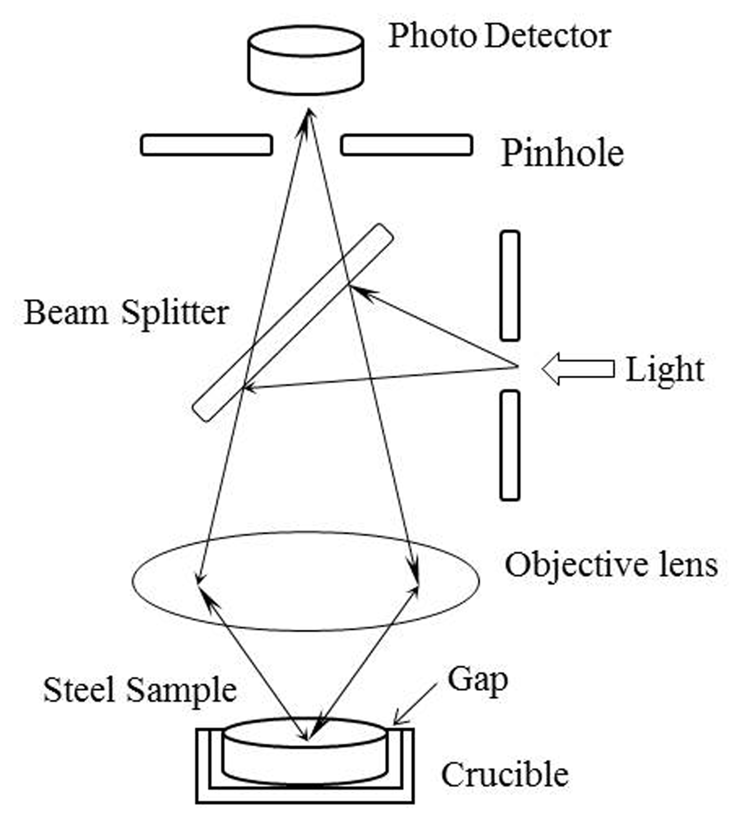

Fig. 1. Confocal nature of the optics.

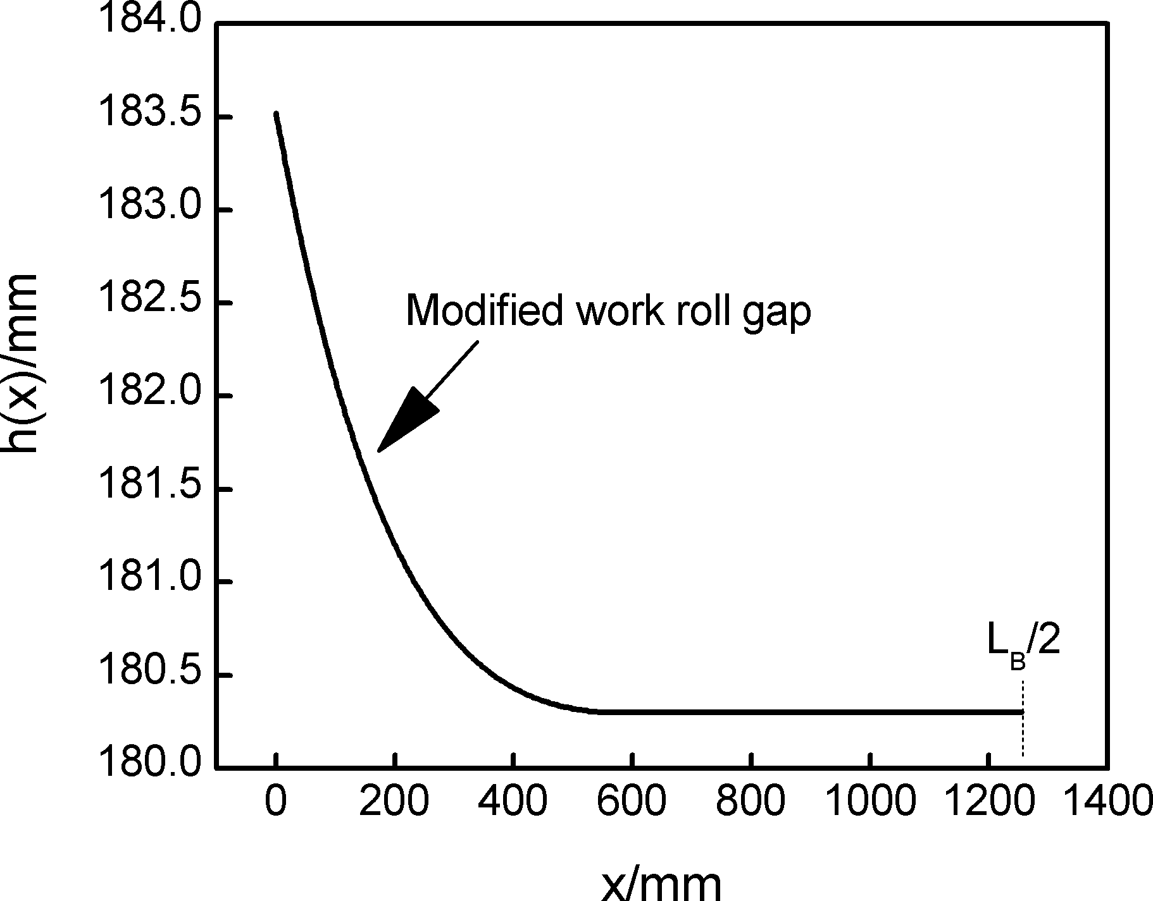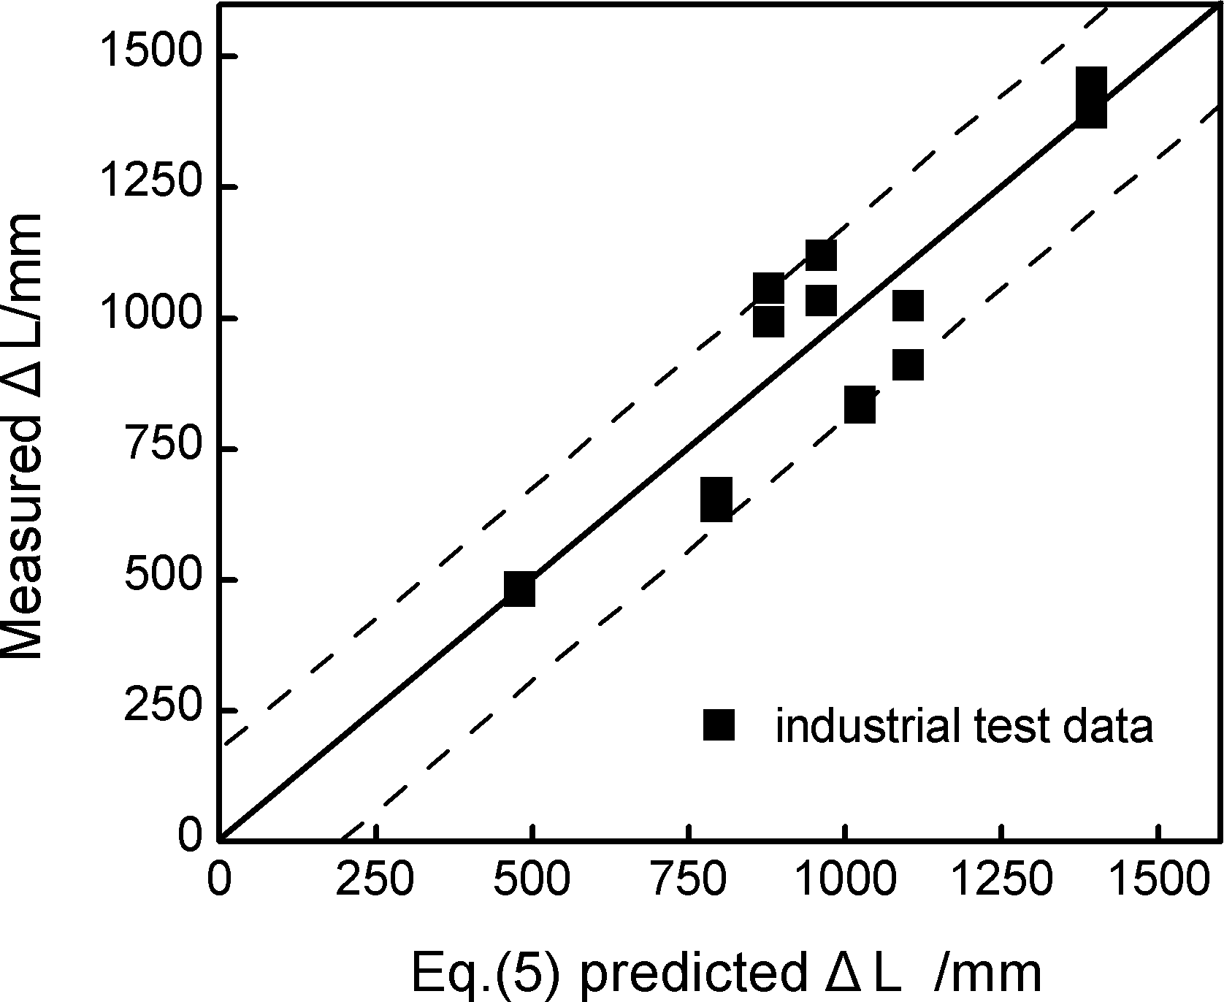

Fig. 2. Temperature change during experiment.
The chemical compositions of the tested steels are illustrated in Table 1.
Table 1
Chemical compositions of tested steels (wt.%)
Steel | C | Si | Mn | S | P | Ni | Cr | Cu | V | Nb | Fe
0.039Nb | 0.22 | 0.53 | 1.43 | 0.022 | 0.030 | 0.019 | 0.021 | 0.080 | 0.004 | 0.039 | Balance
0.024Nb-0.032V | 0.24 | 0.50 | 1.48 | 0.024 | 0.027 | 0.030 | 0.084 | 0.090 | 0.032 | 0.024 | Balance
Table 2
Tensile properties of tested steels
Steel | Tensile property
Steel | R_{el}/ MPa | R_{m}/ MPa | Rm/R_{el} | A/ % | A_{gt}/ %
0.039Nb | 492 | 748 | 1.52 | 22.0 | 14.0
0.024Nb-0.032V | 495 | 720 | 1.45 | 24.1 | 15.0
Note: R_{el}−yield strength; R_{m}−high tensile strength.

3. Results and Discussion

3.1. Original optical microstructure

Original optical microstructures of the tested steels are shown in Fig. 3(a,b).
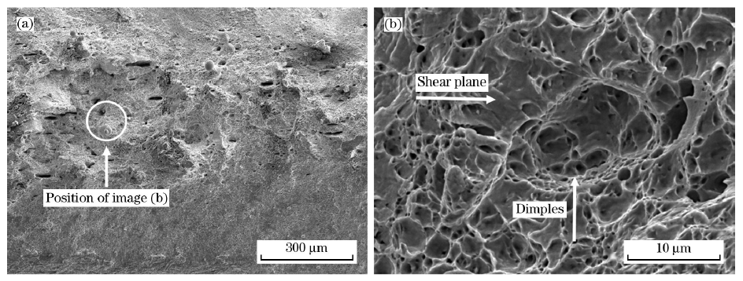
Fig. 3. SEM tensile fractographs of B1500HS
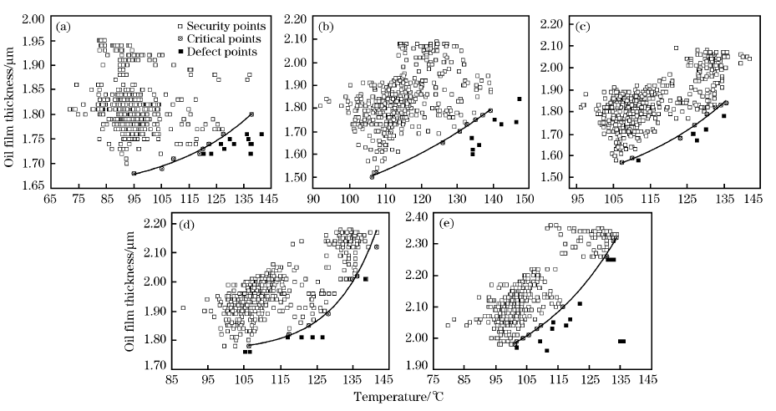
Fig. 4.
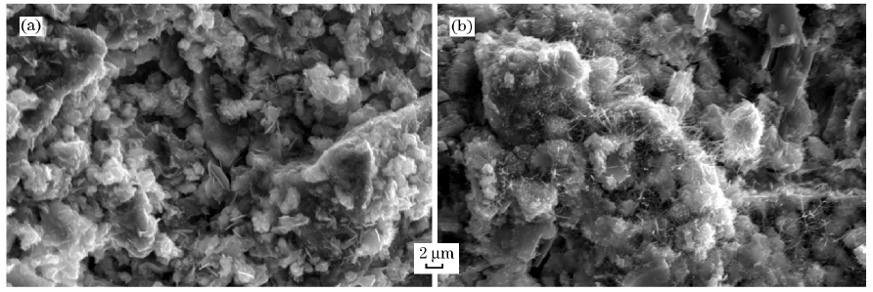
Fig. 5.

3.2. True stress-true strain curves
The true stress-true strain values were transferred from the engineering stress-engineering strain values, and the relationship between true stress-true strain and engineering stress- engineering strain can be described as the following equations:
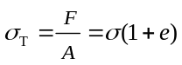 (1)
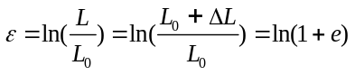 (2)
where, σ_{T}, σ, e, ε, F, A, , L₀, and ∆ represent true stress, engineering stress, engineering strain, true strain, applied load, original cross-sectional area, instantaneous length of sample, original length of sample, and elongation, respectively.

4. Conclusions

(1) The precipitation of titanium nitride on primary inclusion particles completed before the steel solidified due to rapid early growth. There were no size changes of the inclusion near the end of solidification.
(2) The morphology and the volume fraction of bainite will influence the mechanical properties of steel with multi-phase microstructure. Increasing bainite content in tested steel can improve the tensile strength, but reduce the plasticity and toughness.

Acknowledgment

This work was financially supported by the National Natural Science Foundation of China (51261009).

References

- X. Yang, F. M. Sun, J. L. Yang, F. Liu, K. S. Cheng, J. H. Wang, Optimization of Low Phosphorus Steel Production With Double Slag Process in BOF, J. Iron Steel Res. Int. 20 (2013) No. 8, 41-47.
- G. V. Pervushin, H. Suito, Effect of Primary Deoxidation Products of Al2O3, ZrO2, Ce2O3 and MgO on TiN Precipitation in Fe–10mass% Ni Alloy, ISIJ Int. 41 (2001) 748-756.
- L. Yang, S.J. Li, G.G. Cheng, M. Zhao, G.P. Feng, T. Li, A coupled model of TiN inclusion growth in GCr15SiMn during solidification in the electroslag remelting process, Int. J. Miner. Metall. Mater. 22 (2015) 1266-1272.
- Z. Wang, J.J. Li, L.W. Ren, Y. Zhang, J.W. Qiao, B.C. Wang, Serration Behavior in Zr-Cu-Al Glass-forming Systems, J. Iron Steel Res. Int. 23 (2016) 42-47.
- A. N. Assis, J. Warnett, S. Spooner, R. J. Fruehan, M. A. Williams, S. Sridhar, Spontaneous Emulsification of a Metal Drop Immersed in Slag Due to Dephosphorization: Surface Area Quantification, Metall. Mater. Trans. B 46 (2015) 568-576.
- Z. H. Tian, B. H. Li, X. M. Zhang, Z. H. Jiang, Double Slag Operation Dephosphorization in BOF for Producing Low Phosphorus Steel, J. Iron Steel Res. Int. 16 (2009) No. 3, 6-14.
- Y.C. Lv, X.H. Wang, D.P. Qin, H.B. Wang, Enrichment and influencing factors of phosphorus in slag of converter steelmaking, Iron and Steel 52 (2017) No. 10, 29-37 (in Chinese).
- K. I. Naito, N. Asahara, M. Wakoh, T. Matsumiya, Fundamental Study on Effects of Various Factors on Fluid Behavior during Intermediate Deslagging of MURC (Multi-Refining Converter) Process, Tetsu-to-Hagane 100 (2014) 522-529 (in Japanese).
- G.R. Mettam, L.B. Adams, in: B.S. Jones, R.Z. Smith (Eds.), Introduction to the Electronic Age, E-Publishing, Inc., New York, 1994, pp. 281-304.
- W. Strunk Jr., E.B. White, The Elements of Style, 3rd ed., Macmillan, New York, 1979.
- C.J. Won, Method for Manufacturing Hot Rolled Galvanized Steel Sheet at High Speed with Pickling Skipped, US, 6258186B1, 2001.
- Kosaya Gora Iron Works, Briquette Production Technology. http://www.kmz-tula.ru/about-production-briquettes_en.html [accessed: 01.03.2017].

 *Corresponding author. Prof., Ph.D. Email address: jisri@cisri.com.cn (Y.Q. Wang). Received 7 December 2016; Received in revised form 10 January 2017; Accepted 10 January 2017 Available online 15 July 2017 1006-706X/Copyright © 2017, The editorial office of Journal of Iron and Steel Research, International. Published by Elsevier Limited. All rights reserved.

